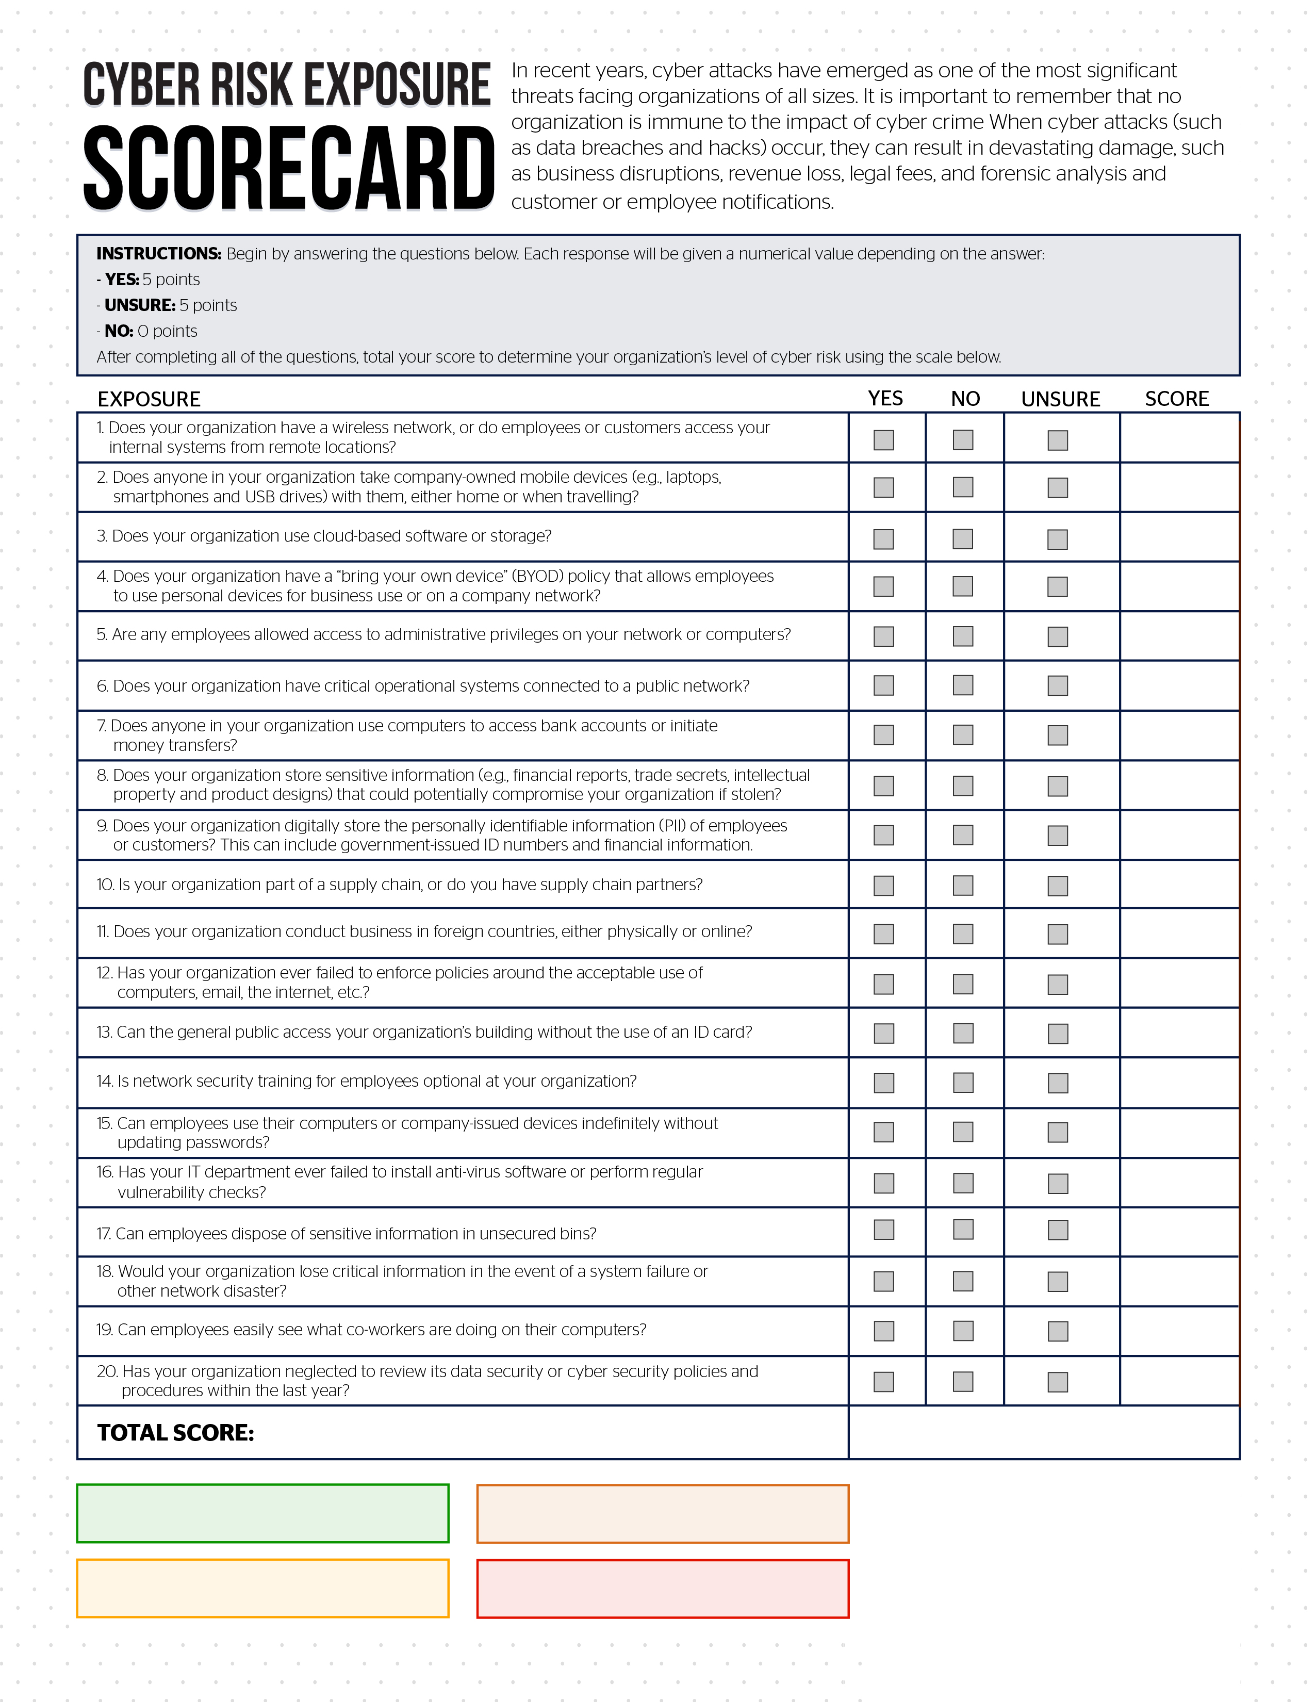

Low risk. Review cyber policy and procedures, and contact us with questions: 0-10
High risk. Contact us today: 30-50
Moderate risk. Contact us for assistance: 15-25
Escalated risk. Contact us now: 55-100

